Dear New Sarepta Community High School families,

New Sarepta Community High School has arranged for students to receive a special discount on Castle Rock Research study guides for grades 3-12 in Mathematics, English Language Arts, Science and Social Studies.

These print and digital resources are all updated to reflect the 2023-24 curriculum. They are a great support for all students, including those taking diploma exams representing 30% of their final marks.

Check out the options and visit https://schoolorders.solaro.com/3220 to place your order between March 11-29. Orders will be individually packaged and shipped to the school for pick up by your students within a week of closing.
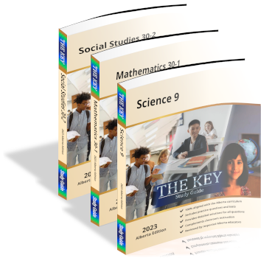
The KEY Study Guides, $25.00 per copy ($34.99 retail)
- New Pre-Test/Post-Test sections; Pre-Tests assess skills from the previous grade, Post-Tests reflect course content in which students must demonstrate proficiency
- Grade 12 Math and Science resources have been updated to include questions from recently released Diploma exams, along with complete detailed solutions.

Student Notes and Problems (SNAP) Workbooks, $25.00 per copy ($34.99 retail)
Instructional content, practice exercises and unit assessments covering the breadth and depth of select Science and Mathematics courses.

Problem Solved and Class Notes, $17.00 per copy ($24.95 retail)
All of the questions from the respective SNAP workbooks are presented along with the detailed solutions. Included are excerpts that focus students on the explanatory notes for each topic.

SOLARO – $25.00 for an annual student license ($200 retail)
- One-year access to up to 10 courses across grades 3-12 in Mathematics, English Language Arts, Science and Social Studies
- Available on any desktop, laptop or mobile browser
- Includes additional quizzes, tests and study tools
- Visit www.solaro.ca/ for more information

Thank you,
New Sarepta Community High School

